Code Listings

Component App

Ivan White

# Component App Version 1.0 Class Diagram

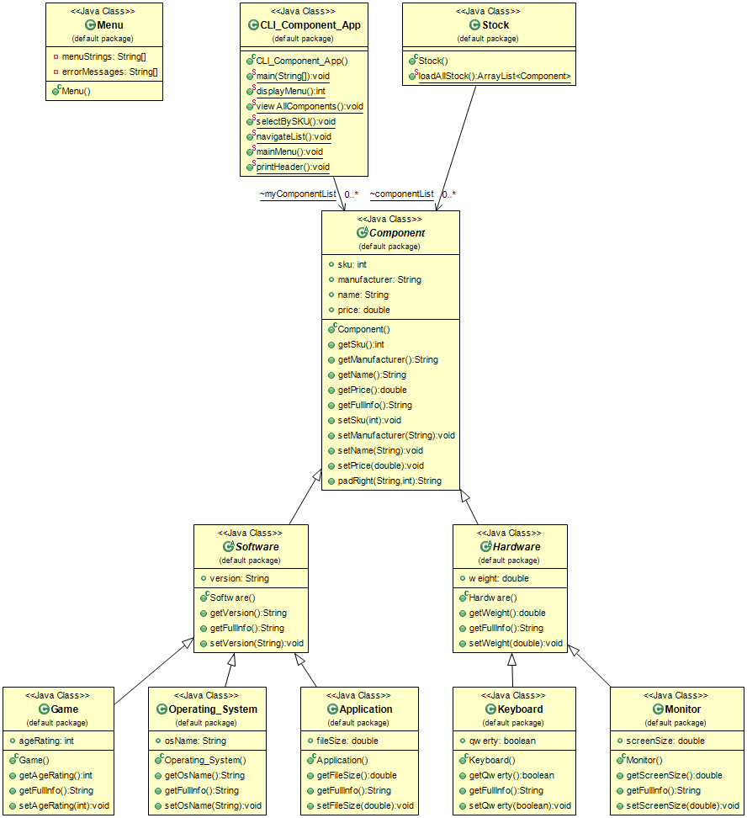

# Component App Version 1.1 Class Diagram

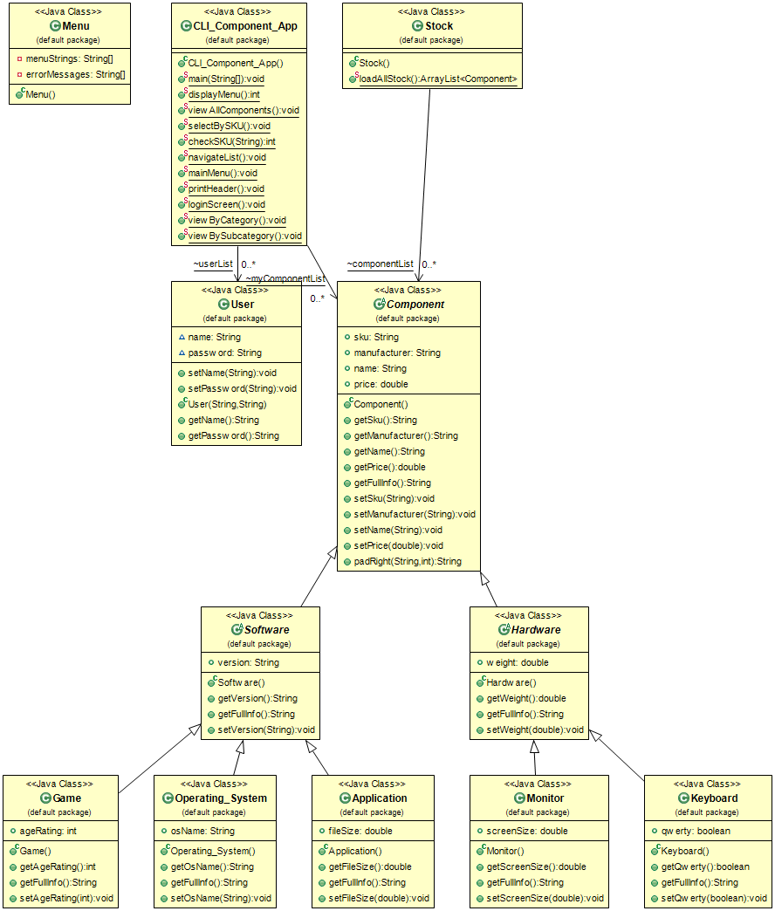

# Version 1.0 Code Listing

Application Class

// Author: Ivan White

// Software Development Course Module: Software Architecture Skills Demo

// AIS Code: 6N1449

// Date: 23rd July 2019

**public** **class** Application **extends** Software {

**public** **double** fileSize;

// Getters

**public** **double** getFileSize() {

**return** fileSize;

}

**public** String getFullInfo() {

**return** **super**.getFullInfo() + padRight("File size: " + String.*valueOf*(fileSize) + "GB", 20);

}

// Setters

**public** **void** setFileSize(**double** fs) {

fileSize = fs;

}

}

Component Class

// Author: Ivan White

// Software Development Course Module: Software Architecture Skills Demo

// AIS Code: 6N1449

// Date: 23rd July 2019

**public** **abstract** **class** Component {

**public** **int** sku;

**public** String manufacturer;

**public** String name;

**public** **double** price;

// Getters

**public** **int** getSku() {

**return** sku;

}

**public** String getManufacturer() {

**return** manufacturer;

}

**public** String getName() {

**return** name;

}

**public** **double** getPrice() {

**return** price;

}

**public** String getFullInfo() {

**return** padRight(String.*valueOf*(sku), 9) + padRight(name, 25) + padRight(String.*valueOf*(price), 10)

+ padRight(manufacturer, 15);

}

// Setters

**public** **void** setSku(**int** s) {

sku = s;

}

**public** **void** setManufacturer(String m) {

manufacturer = m;

}

**public** **void** setName(String n) {

name = n;

}

**public** **void** setPrice(**double** p) {

price = p;

}

**public** String padRight(String s, **int** n) {

**return** String.*format*("%-" + n + "s", s);

}

}

Game Class

// Author: Ivan White

// Software Development Course Module: Software Architecture Skills Demo

// AIS Code: 6N1449

// Date: 23rd July 2019

**public** **class** Game **extends** Software {

**public** **int** ageRating;

// Getters

**public** **int** getAgeRating() {

**return** ageRating;

}

**public** String getFullInfo() {

**return** **super**.getFullInfo() + padRight("Age rating: " + String.*valueOf*(ageRating), 20);

}

// Setters

**public** **void** setAgeRating(**int** ar) {

ageRating = ar;

}

}

Hardware Class

// Author: Ivan White

// Software Development Course Module: Software Architecture Skills Demo

// AIS Code: 6N1449

// Date: 23rd July 2019

**public** **class** Game **extends** Software {

**public** **int** ageRating;

// Getters

**public** **int** getAgeRating() {

**return** ageRating;

}

**public** String getFullInfo() {

**return** **super**.getFullInfo() + padRight("Age rating: " + String.*valueOf*(ageRating), 20);

}

// Setters

**public** **void** setAgeRating(**int** ar) {

ageRating = ar;

}

}

Keyboard Class

// Author: Ivan White

// Software Development Course Module: Software Architecture Skills Demo

// AIS Code: 6N1449

// Date: 23rd July 2019

**public** **class** Keyboard **extends** Hardware {

**public** **boolean** qwerty;

// Getters

**public** **boolean** getQwerty() {

**return** qwerty;

}

**public** String getFullInfo() {

**return** **super**.getFullInfo() + padRight("Qwerty = " + qwerty, 20);

}

// Setters

**public** **void** setQwerty(**boolean** q) {

qwerty = q;

}

}

Menu Class

// Author: Ivan White

// Software Development Course Module: Software Architecture Skills Demo

// AIS Code: 6N1449

// Date: 23rd July 2019

**public** **class** Menu {

**private** String[] menuStrings;

**private** String[] errorMessages;

}

Monitor Class

// Author: Ivan White

// Software Development Course Module: Software Architecture Skills Demo

// AIS Code: 6N1449

// Date: 23rd July 2019

**public** **class** Monitor **extends** Hardware {

**public** **double** screenSize;

// Getters

**public** **double** getScreenSize() {

**return** screenSize;

}

**public** String getFullInfo() {

**return** **super**.getFullInfo() + padRight("Screen size: " + String.*valueOf*(screenSize), 20);

}

// Setters

**public** **void** setScreenSize(**double** ss) {

screenSize = ss;

}

}

Operating System Class

// Author: Ivan White

// Software Development Course Module: Software Architecture Skills Demo

// AIS Code: 6N1449

// Date: 23rd July 2019

**public** **class** Operating_System **extends** Software {

**public** String osName;

// Getters

**public** String getOsName() {

**return** osName;

}

**public** String getFullInfo() {

**return** **super**.getFullInfo() + padRight(osName, 20);

}

// Setters

**public** **void** setOsName(String osn) {

osName = osn;

}

}

Software Class

// Author: Ivan White

// Software Development Course Module: Software Architecture Skills Demo

// AIS Code: 6N1449

// Date: 23rd July 2019

**public** **abstract** **class** Software **extends** Component {

**public** String version;

// Getters

**public** String getVersion() {

**return** version;

}

**public** String getFullInfo() {

**return** **super**.getFullInfo() + padRight(version, 18);

}

// Setters

**public** **void** setVersion(String v) {

version = v;

}

}

Stock Class

// Author: Ivan White

// Software Development Course Module: Software Architecture Skills Demo

// AIS Code: 6N1449

// Date: 23rd July 2019

**import** java.util.ArrayList;

**public** **class** Stock {

**static** ArrayList<Component> *componentList* = **new** ArrayList<>();

**public** **static** ArrayList<Component> loadAllStock() {

Operating_System os1 = **new** Operating_System();

os1.setManufacturer("Microsoft");

os1.setOsName("Windows 10");

os1.setPrice(130);

os1.setSku(10001);

os1.setVersion("version 1.0");

os1.setName("operating software");

Operating_System os2 = **new** Operating_System();

os2.setManufacturer("Microsoft");

os2.setOsName("Windows 8");

os2.setPrice(110);

os2.setSku(10002);

os2.setVersion("version 1.1");

os2.setName("operating software");

Game g1 = **new** Game();

g1.setManufacturer("Activision");

g1.setName("Call of Duty");

g1.setPrice(60);

;

g1.setSku(10003);

g1.setAgeRating(18);

g1.setVersion("version 1.1");

Application ap1 = **new** Application();

ap1.setManufacturer("microsoft");

ap1.setName("Excel");

ap1.setPrice(110);

ap1.setSku(10004);

ap1.setFileSize(250);

ap1.setVersion("version 1.5");

ap1.setFileSize(1.2);

Monitor m1 = **new** Monitor();

m1.setManufacturer("Fujitsu");

m1.setPrice(110);

m1.setName("monitor");

m1.setScreenSize(27);

m1.setSku(10005);

m1.setWeight(1.0);

Keyboard k1 = **new** Keyboard();

k1.setManufacturer("Logitech");

k1.setName("keyboard");

k1.setPrice(110.0);

k1.setQwerty(**true**);

k1.setSku(10006);

k1.setWeight(5);

Monitor m2 = **new** Monitor();

m2.setName("monitor");

m2.setPrice(115.0);

m2.setManufacturer("HP");

m2.setWeight(1.5);

m2.setScreenSize(32);

m2.setSku(10007);

Monitor m3 = **new** Monitor();

m3.setName("monitor");

m3.setPrice(120.0);

m3.setManufacturer("ASUS");

m3.setWeight(2.0);

m3.setScreenSize(40);

m3.setSku(10008);

*componentList*.add(os1);

*componentList*.add(os2);

*componentList*.add(g1);

*componentList*.add(ap1);

*componentList*.add(m1);

*componentList*.add(k1);

*componentList*.add(m2);

*componentList*.add(m3);

**return** *componentList*;

}

}

CLI Component App Class

// Author: Ivan White

// Software Development Course Module: Software Architecture Skills Demo

// AIS Code: 6N1449

// Date: 23rd July 2019

**import** java.util.ArrayList;

**import** java.util.Scanner;

**public** **class** CLI_Component_App {

**static** ArrayList<Component> *myComponentList* = **new** ArrayList<>();

**public** **static** **void** main(String[] args) {

*myComponentList* = Stock.*loadAllStock*();

*mainMenu*();

}

**public** **static** **int** displayMenu() {

Scanner sc = **new** Scanner(System.***in***);

**int** userOption;

System.***out***.println("1. View All Components");

System.***out***.println("2. Select Component by SKU");

System.***out***.println("3. Navigate through List of Components");

System.***out***.println("4. Exit System\n");

System.***out***.println("Please select an option");

userOption = sc.nextInt();

**return** userOption;

}

**public** **static** **void** viewAllComponents() {

*printHeader*();

**for** (**int** i = 0; i < *myComponentList*.size(); i++) {

System.***out***.println(*myComponentList*.get(i).getFullInfo());

}

System.***out***.println(

"===========================================================================================================");

*mainMenu*();

}

**public** **static** **void** selectBySKU() {

Scanner sc = **new** Scanner(System.***in***);

**int** sku;

**do** {

System.***out***.println("Please enter an SKU or press 0 to go back to main menu");

sku = sc.nextInt();

*printHeader*();

**for** (**int** i = 0; i < *myComponentList*.size(); i++) {

**if** (sku == *myComponentList*.get(i).getSku()) {

System.***out***.println(*myComponentList*.get(i).getFullInfo() + "\n");

}

}

} **while** (sku != 0);

*mainMenu*();

}

**public** **static** **void** navigateList() {

Scanner sc = **new** Scanner(System.***in***);

**int** opt = 0;

**int** indexSelected = 0;

*printHeader*();

// Display first component

System.***out***.println(*myComponentList*.get(indexSelected).getFullInfo());

**do** {

System.***out***.println("1. First Component");

System.***out***.println("2. Next component");

System.***out***.println("3. Previous Component");

System.***out***.println("4. Last Component");

System.***out***.println("5. Back to Main Menu\n");

System.***out***.println("Please select an option");

opt = sc.nextInt();

**switch** (opt) {

**case** 1:

indexSelected = 0;

*printHeader*();

System.***out***.println(*myComponentList*.get(0).getFullInfo());

**break**;

**case** 2:

indexSelected++;

*printHeader*();

System.***out***.println(*myComponentList*.get(indexSelected).getFullInfo());

**break**;

**case** 3:

indexSelected--;

*printHeader*();

System.***out***.println(*myComponentList*.get(indexSelected).getFullInfo());

**break**;

**case** 4:

indexSelected = *myComponentList*.size() - 1;

*printHeader*();

System.***out***.println(*myComponentList*.get(indexSelected).getFullInfo());

**case** 5:

*mainMenu*();

**break**;

**default**:

System.***out***.println("Please enter a valid option!");

**break**;

}

} **while** (opt != 5);

}

**public** **static** **void** mainMenu() {

**int** userOption = *displayMenu*();

**switch** (userOption) {

**case** 1:

*viewAllComponents*();

**break**;

**case** 2:

*selectBySKU*();

**break**;

**case** 3:

*navigateList*();

**break**;

**case** 4:

System.*exit*(0);

**break**;

**default**:

System.***out***.println("Please enter a valid option!");

**break**;

}

}

**public** **static** **void** printHeader() {

System.***out***.println("SKU Name Price Manufacturer Version/Weight Extra Info");

System.***out***.println(

"===========================================================================================================");

}

}

# Version 1.1 Code Listing

Application Class

// Author: Ivan White

// Software Development Course Module: Software Architecture Skills Demo

// AIS Code: 6N1449

// Date: 23rd July 2019

**public** **class** Application **extends** Software {

**public** **double** fileSize;

// Getters

**public** **double** getFileSize() {

**return** fileSize;

}

**public** String getFullInfo() {

**return** **super**.getFullInfo() + padRight("File size: " + String.*valueOf*(fileSize) + "GB", 20);

}

// Setters

**public** **void** setFileSize(**double** fs) {

fileSize = fs;

}

}

Component Class

// Author: Ivan White

// Software Development Course Module: Software Architecture Skills Demo

// AIS Code: 6N1449

// Date: 23rd July 2019

**public** **abstract** **class** Component {

**public** String sku;

**public** String manufacturer;

**public** String name;

**public** **double** price;

// Getters

**public** String getSku() {

**return** sku;

}

**public** String getManufacturer() {

**return** manufacturer;

}

**public** String getName() {

**return** name;

}

**public** **double** getPrice() {

**return** price;

}

**public** String getFullInfo() {

**return** padRight(String.*valueOf*(sku), 9) + padRight(name, 25) + padRight(String.*valueOf*(price), 10)

+ padRight(manufacturer, 15);

}

// Setters

**public** **void** setSku(String s) {

sku = s;

}

**public** **void** setManufacturer(String m) {

manufacturer = m;

}

**public** **void** setName(String n) {

name = n;

}

**public** **void** setPrice(**double** p) {

price = p;

}

**public** String padRight(String s, **int** n) {

**return** String.*format*("%-" + n + "s", s);

}

}

Game Class

// Author: Ivan White

// Software Development Course Module: Software Architecture Skills Demo

// AIS Code: 6N1449

// Date: 23rd July 2019

**public** **class** Game **extends** Software {

**public** **int** ageRating;

// Getters

**public** **int** getAgeRating() {

**return** ageRating;

}

**public** String getFullInfo() {

**return** **super**.getFullInfo() + padRight("Age rating: " + String.*valueOf*(ageRating), 20);

}

// Setters

**public** **void** setAgeRating(**int** ar) {

ageRating = ar;

}

}

Hardware Class

// Author: Ivan White

// Software Development Course Module: Software Architecture Skills Demo

// AIS Code: 6N1449

// Date: 23rd July 2019

**public** **abstract** **class** Hardware **extends** Component {

**public** **double** weight;

// Getters

**public** **double** getWeight() {

**return** weight;

}

**public** String getFullInfo() {

**return** **super**.getFullInfo() + padRight(String.*valueOf*(weight) + " Kgs", 18);

}

// Setters

**public** **void** setWeight(**double** w) {

weight = w;

}

}

Keyboard Class

// Author: Ivan White

// Software Development Course Module: Software Architecture Skills Demo

// AIS Code: 6N1449

// Date: 23rd July 2019

**public** **class** Keyboard **extends** Hardware {

**public** **boolean** qwerty;

// Getters

**public** **boolean** getQwerty() {

**return** qwerty;

}

**public** String getFullInfo() {

**return** **super**.getFullInfo() + padRight("Qwerty = " + qwerty, 20);

}

// Setters

**public** **void** setQwerty(**boolean** q) {

qwerty = q;

}

}

Menu Class

// Author: Ivan White

// Software Development Course Module: Software Architecture Skills Demo

// AIS Code: 6N1449

// Date: 23rd July 2019

**public** **class** Menu {

**private** String[] menuStrings;

**private** String[] errorMessages;

}

Monitor Class

// Author: Ivan White

// Software Development Course Module: Software Architecture Skills Demo

// AIS Code: 6N1449

// Date: 23rd July 2019

**public** **class** Monitor **extends** Hardware {

**public** **double** screenSize;

// Getters

**public** **double** getScreenSize() {

**return** screenSize;

}

**public** String getFullInfo() {

**return** **super**.getFullInfo() + padRight("Screen size: " + String.*valueOf*(screenSize), 20);

}

// Setters

**public** **void** setScreenSize(**double** ss) {

screenSize = ss;

}

}

Operating System Class

// Author: Ivan White

// Software Development Course Module: Software Architecture Skills Demo

// AIS Code: 6N1449

// Date: 23rd July 2019

**public** **class** Operating_System **extends** Software {

**public** String osName;

// Getters

**public** String getOsName() {

**return** osName;

}

**public** String getFullInfo() {

**return** **super**.getFullInfo() + padRight(osName, 20);

}

// Setters

**public** **void** setOsName(String osn) {

osName = osn;

}

}

Software Class

// Author: Ivan White

// Software Development Course Module: Software Architecture Skills Demo

// AIS Code: 6N1449

// Date: 23rd July 2019

**public** **abstract** **class** Software **extends** Component {

**public** String version;

// Getters

**public** String getVersion() {

**return** version;

}

**public** String getFullInfo() {

**return** **super**.getFullInfo() + padRight(version, 18);

}

// Setters

**public** **void** setVersion(String v) {

version = v;

}

}

Stock Class

// Author: Ivan White

// Software Development Course Module: Software Architecture Skills Demo

// AIS Code: 6N1449

// Date: 23rd July 2019

**import** java.util.ArrayList;

**public** **class** Stock {

**static** ArrayList<Component> *componentList* = **new** ArrayList<>();

**public** **static** ArrayList<Component> loadAllStock() {

Operating_System os1 = **new** Operating_System();

os1.setManufacturer("Microsoft");

os1.setOsName("Windows 10");

os1.setPrice(130);

os1.setSku("SOS10001");

os1.setVersion("version 1.0");

os1.setName("operating software");

Operating_System os2 = **new** Operating_System();

os2.setManufacturer("Microsoft");

os2.setOsName("Windows 8");

os2.setPrice(110);

os2.setSku("SOS10002");

os2.setVersion("version 1.1");

os2.setName("operating software");

Game g1 = **new** Game();

g1.setManufacturer("Activision");

g1.setName("Call of Duty");

g1.setPrice(60);

g1.setSku("SGA10003");

g1.setAgeRating(18);

g1.setVersion("version 1.1");

Application ap1 = **new** Application();

ap1.setManufacturer("Microsoft");

ap1.setName("Excel");

ap1.setPrice(110);

ap1.setSku("SAP10004");

ap1.setFileSize(250);

ap1.setVersion("version 1.5");

ap1.setFileSize(1.2);

Monitor m1 = **new** Monitor();

m1.setManufacturer("Fujitsu");

m1.setPrice(110);

m1.setName("monitor");

m1.setScreenSize(27);

m1.setSku("HMO10005");

m1.setWeight(1.0);

Keyboard k1 = **new** Keyboard();

k1.setManufacturer("Logitech");

k1.setName("keyboard");

k1.setPrice(110.0);

k1.setQwerty(**true**);

k1.setSku("HKE10006");

k1.setWeight(5);

Monitor m2 = **new** Monitor();

m2.setName("monitor");

m2.setPrice(115.0);

m2.setManufacturer("HP");

m2.setWeight(1.5);

m2.setScreenSize(32);

m2.setSku("HMO10007");

Monitor m3 = **new** Monitor();

m3.setName("monitor");

m3.setPrice(120.0);

m3.setManufacturer("ASUS");

m3.setWeight(2.0);

m3.setScreenSize(40);

m3.setSku("HMO10008");

*componentList*.add(os1);

*componentList*.add(os2);

*componentList*.add(g1);

*componentList*.add(ap1);

*componentList*.add(m1);

*componentList*.add(k1);

*componentList*.add(m2);

*componentList*.add(m3);

**return** *componentList*;

}

}

User Class

**public** **class** User {

String name;

String password;

// Setters

**public** **void** setName(String n) {

name = n;

}

**public** **void** setPassword(String p) {

password = p;

}

**public** User(String n, String p) {

name = n;

password = p;

}

// Getters

**public** String getName() {

**return** name;

}

**public** String getPassword() {

**return** password;

}

}

CLI Component App Class

// Author: Ivan White

// Software Development Course Module: Software Architecture Skills Demo

// AIS Code: 6N1449

// Date: 23rd July 2019

**import** java.util.ArrayList;

**import** java.util.Scanner;

**public** **class** CLI_Component_App {

**static** ArrayList<Component> *myComponentList* = **new** ArrayList<>();

**static** ArrayList<User> *userList* = **new** ArrayList<>();

**public** **static** **void** main(String[] args) {

// Loads stock

*myComponentList* = Stock.*loadAllStock*();

// Loads user list (only one user for now)

*userList*.add(**new** User("test", "1234"));

System.***out***.println("For testing purposes the username is: " + *userList*.get(0).getName());

System.***out***.println("For testing purposes the password is: " + *userList*.get(0).getPassword());

*loginScreen*();

*mainMenu*();

}

**public** **static** **int** displayMenu() {

Scanner sc = **new** Scanner(System.***in***);

**int** userOption;

System.***out***.println("\n/////////////////////////////////////");

System.***out***.println("Main Menu");

System.***out***.println("/////////////////////////////////////\n");

System.***out***.println("1. View All Components");

System.***out***.println("2. Select Component by SKU");

System.***out***.println("3. Navigate through List of Components");

System.***out***.println("4. View by Category");

System.***out***.println("5. View by Sub-Category");

System.***out***.println("6. Exit System\n");

System.***out***.println("Please select an option");

userOption = sc.nextInt();

**return** userOption;

}

**public** **static** **void** viewAllComponents() {

*printHeader*();

**for** (**int** i = 0; i < *myComponentList*.size(); i++) {

System.***out***.println(*myComponentList*.get(i).getFullInfo());

}

System.***out***.println(

"===========================================================================================================");

*mainMenu*();

}

**public** **static** **void** selectBySKU() {

Scanner sc = **new** Scanner(System.***in***);

String skuEntered;

**do** {

System.***out***.println("Please enter an SKU or press Q to go back to main menu");

skuEntered = sc.nextLine();

// Called the checkSKU method within the if condition

**if** (*checkSKU*(skuEntered) > -1) {

*printHeader*();

System.***out***.println(*myComponentList*.get(*checkSKU*(skuEntered)).getFullInfo() + "\n");

} **else** {

System.***out***.println("No component with that SKU found. Please try again.");

}

} **while** (!skuEntered.equalsIgnoreCase("q"));

*mainMenu*();

}

// Checks that the SKU entered is found within the components list

**public** **static** **int** checkSKU(String sku) {

**int** skuIndex = -1;

**for** (**int** i = 0; i < *myComponentList*.size(); i++) {

**if** (sku.equalsIgnoreCase(*myComponentList*.get(i).getSku())) {

skuIndex = i;

i = *myComponentList*.size();

}

}

**return** skuIndex;

}

**public** **static** **void** navigateList() {

Scanner sc = **new** Scanner(System.***in***);

String opt;

**int** indexSelected = 0;

**int** listSize = *myComponentList*.size() - 1;

//Prints the header from the printHeader method

*printHeader*();

// Display first component

System.***out***.println(*myComponentList*.get(indexSelected).getFullInfo() + "\n");

**do** {

System.***out***.println("1. First Component");

System.***out***.println("2. Next component");

System.***out***.println("3. Previous Component");

System.***out***.println("4. Last Component");

System.***out***.println("5. Back to Main Menu\n");

System.***out***.println("Please select an option");

opt = sc.nextLine();

**switch** (opt) {

**case** "1":

indexSelected = 0;

*printHeader*();

System.***out***.println(*myComponentList*.get(0).getFullInfo() + "\n");

**break**;

**case** "2":

**if** (indexSelected < listSize) // Goes back to start of list if last item is selected

indexSelected++;

**else**

indexSelected = 0;

*printHeader*();

System.***out***.println(*myComponentList*.get(indexSelected).getFullInfo() + "\n");

**break**;

**case** "3":

**if** (indexSelected == 0) // Goes to end of list of first item is selected

indexSelected = *myComponentList*.size() - 1;

**else**

indexSelected--;

*printHeader*();

System.***out***.println(*myComponentList*.get(indexSelected).getFullInfo() + "\n");

**break**;

**case** "4":

indexSelected = *myComponentList*.size() - 1;

*printHeader*();

System.***out***.println(*myComponentList*.get(indexSelected).getFullInfo() + "\n");

**break**;

**case** "5":

*mainMenu*();

**break**;

**default**:

System.***out***.println("\nPlease enter a valid option!");

**break**;

}

} **while** (opt != "5");

}

**public** **static** **void** mainMenu() {

**int** userOption = *displayMenu*();

**switch** (userOption) {

**case** 1:

*viewAllComponents*();

**break**;

**case** 2:

*selectBySKU*();

**break**;

**case** 3:

*navigateList*();

**break**;

**case** 4:

*viewByCategory*();

**break**;

**case** 5:

*viewBySubcategory*();

**break**;

**case** 6:

System.***out***.println("GOODBYE!");

System.*exit*(0);

**break**;

**default**:

System.***out***.println("\nPlease enter a valid option!");

**break**;

}

}

// This method prints the labels for each column

**public** **static** **void** printHeader() {

System.***out***.println("SKU Name Price Manufacturer Version/Weight Extra Info");

System.***out***.println(

"===========================================================================================================");

}

**public** **static** **void** loginScreen() {

Scanner sc = **new** Scanner(System.***in***);

String nameEntered;

String passwordEntered;

**boolean** isLoggedIn = **false**;

**do** {

System.***out***.println(

"===========================================================================================================");

System.***out***.println("Login To Component App");

System.***out***.println(

"===========================================================================================================");

System.***out***.println("Please enter a username:");

nameEntered = sc.nextLine();

System.***out***.println(

"===========================================================================================================");

System.***out***.println("Please enter a password:");

passwordEntered = sc.nextLine();

**for** (**int** i = 0; i < *userList*.size(); i++) {

**if** (nameEntered.equals(*userList*.get(i).getName())

&& passwordEntered.equals(*userList*.get(i).getPassword())) {

System.***out***.println("\nWelcome, " + nameEntered + "\n");

isLoggedIn = **true**;

} **else** {

System.***out***.println("Login details incorrect! Please try again");

// Name and password hint if incorrectly entered (for testing purposes only!)

System.***out***.println("Hint: " + *userList*.get(0).getName() + ", " + *userList*.get(0).getPassword());

}

}

} **while** (isLoggedIn == **false**);

}

**public** **static** **void** viewByCategory() {

Scanner sc = **new** Scanner(System.***in***);

String optionSelected;

**do** {

System.***out***.println("\n\nPlease select an option\n");

System.***out***.println("1. View Hardware");

System.***out***.println("2. View Software");

System.***out***.println("3. Return to Main Menu");

optionSelected = sc.nextLine();

**switch** (optionSelected) {

**case** "1":

*printHeader*();

**for** (**int** i = 0; i < *myComponentList*.size(); i++) {

String checksku = *myComponentList*.get(i).getSku();

**if** (checksku.substring(0, 1).equals("H")) {

System.***out***.println(*myComponentList*.get(i).getFullInfo());

}

}

**break**;

**case** "2":

*printHeader*();

**for** (**int** i = 0; i < *myComponentList*.size(); i++) {

String checksku = *myComponentList*.get(i).getSku();

**if** (checksku.substring(0, 1).equals("S")) {

System.***out***.println(*myComponentList*.get(i).getFullInfo());

}

}

**break**;

**case** "3":

*mainMenu*();

**break**;

**default**:

System.***out***.println("\nPlease enter a valid option!");

**break**;

}

} **while** (optionSelected != "3");

}

**public** **static** **void** viewBySubcategory() {

Scanner sc = **new** Scanner(System.***in***);

String optionSelected;

**do** {

System.***out***.println("\n\nPlease select an option\n");

System.***out***.println("1. View Applications");

System.***out***.println("2. View Games");

System.***out***.println("3. View Keyboards");

System.***out***.println("4. View Monitors");

System.***out***.println("5. View Operating Systems");

System.***out***.println("6. Return to Main Menu");

optionSelected = sc.nextLine();

**switch** (optionSelected) {

**case** "1":

*printHeader*();

**for** (**int** i = 0; i < *myComponentList*.size(); i++) {

String checksku = *myComponentList*.get(i).getSku();

**if** (checksku.substring(0, 3).equals("SAP")) {

System.***out***.println(*myComponentList*.get(i).getFullInfo());

}

}

**break**;

**case** "2":

*printHeader*();

**for** (**int** i = 0; i < *myComponentList*.size(); i++) {

String checksku = *myComponentList*.get(i).getSku();

**if** (checksku.substring(0, 3).equals("SGA")) {

System.***out***.println(*myComponentList*.get(i).getFullInfo());

}

}

**break**;

**case** "3":

*printHeader*();

**for** (**int** i = 0; i < *myComponentList*.size(); i++) {

String checksku = *myComponentList*.get(i).getSku();

**if** (checksku.substring(0, 3).equals("HKE")) {

System.***out***.println(*myComponentList*.get(i).getFullInfo());

}

}

**break**;

**case** "4":

*printHeader*();

**for** (**int** i = 0; i < *myComponentList*.size(); i++) {

String checksku = *myComponentList*.get(i).getSku();

**if** (checksku.substring(0, 3).equals("HMO")) {

System.***out***.println(*myComponentList*.get(i).getFullInfo());

}

}

**break**;

**case** "5":

*printHeader*();

**for** (**int** i = 0; i < *myComponentList*.size(); i++) {

String checksku = *myComponentList*.get(i).getSku();

**if** (checksku.substring(0, 3).equals("SOS")) {

System.***out***.println(*myComponentList*.get(i).getFullInfo());

}

}

**break**;

**case** "6":

*mainMenu*();

**break**;

**default**:

System.***out***.println("\nPlease enter a valid option!");

**break**;

}

} **while** (optionSelected != "6");

}

}

# Code Alterations

The user is given a login username and password when they launch the app. This is for testing/examination purposes and would not be included if this application was being developed for a real world project.